**Research Assignment #2**

**\*please read the entire document before starting\***

**To be completed in week 2, and again in week 7 (research team members)**

In this assignment, you will be locating and finding the contact information for key locations in and around our target areas.

If you are in week 2, you will complete this assignment for the area you live in using the hotspots (minimum of 2) that you located in assignment 1. **Please submit a minimum of 10 locations for each of your hotspots.**

If you are in week 7 and have chosen research as your focus, you will complete this assignment using the city you have been assigned and the hotspots (minimum of 5) that you located last week. **Please submit a minimum of 10 locations for each of your hotspots.**

Key locations include: *churches, K-5 schools, community centers, and parks.*

We are also interested in finding events in the community. Neighborhood Rescue can potentially attend these events for either a drawing competition, donation drive, Walk the Street interviews, etc.

You will search for these locations both in and around/near your target areas. If a location is in a target area (high crime, low income), it will be a candidate for our drawing competition or other outreach event. If a location is outside of a target area (has lower crime, higher income), it will be a candidate for a donation drive or other partnership. We want locations from both of these categories and a location should only fall into one, not both, of them.

Being familiar with your hotspots and knowing if a location is in or outside of it is important as this determines which type of phone call you make to the organization (you will learn more about phone calls next week).

From last week’s research, you should be familiar with the streets directly in and slightly outside of your hotspot areas. You should also be familiar with what zip code(s) are in your target areas. These are both preliminary ways of determining if a location is one you should include.

Find and compile the information for as many relevant locations as possible in your hotspot areas. However, please make sure you submit a minimum of 10 locations for each hotspot.

**Step 1 Review previous research**

Review your research from the first research assignment. Focus on the streets and Google Map images you should already have. Take note of any key locations you may already be able to see.

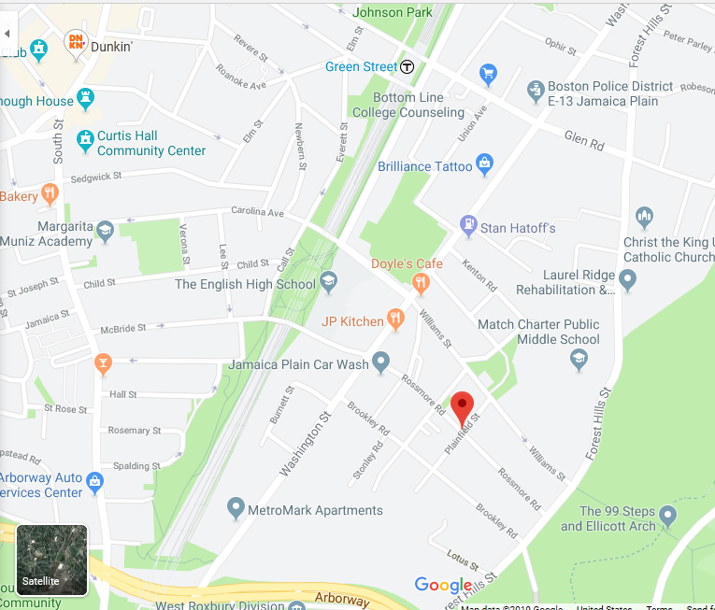

Example: In my image of the Jamaica Plain neighborhood of Boston from last week, I can already see the Curtis Hall Community Center, Johnson Park, Christ the King Ukrainian Catholic Church, some schools, etc.

**Step 2 Use Google Maps**

Return to Google Maps and navigate back to the area you identified last week. Find and review the information for any locations you’ve previously identified (above).

Continue to maneuver/adjust the Google Map, looking for other possible locations. Be aware of your neighborhood boundaries, as defined in the first assignment. Initially, stay within your neighborhood boundaries and compile the information for all locations within the target area. Then, begin to branch out slightly to find locations slightly outside of the target area.

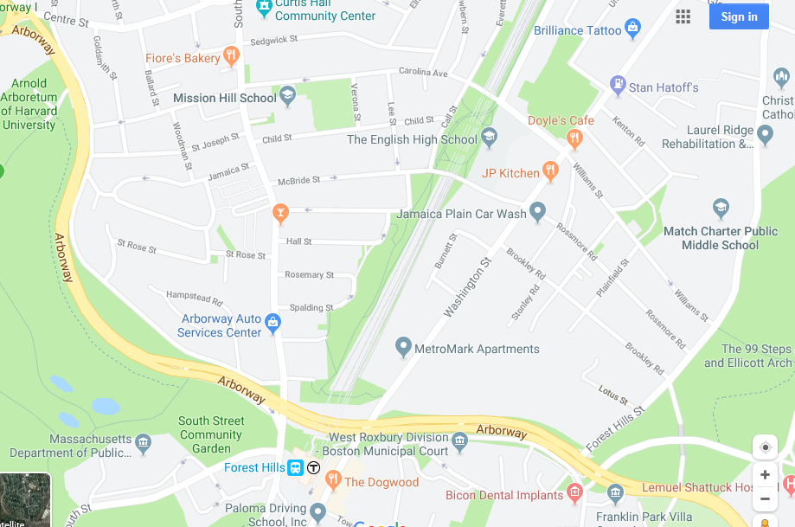

Example: After adjusting the map, I can now also see the South Street Community Garden and Mission Hill School, locations that are still in Jamaica Plain but slightly outside of the target area.

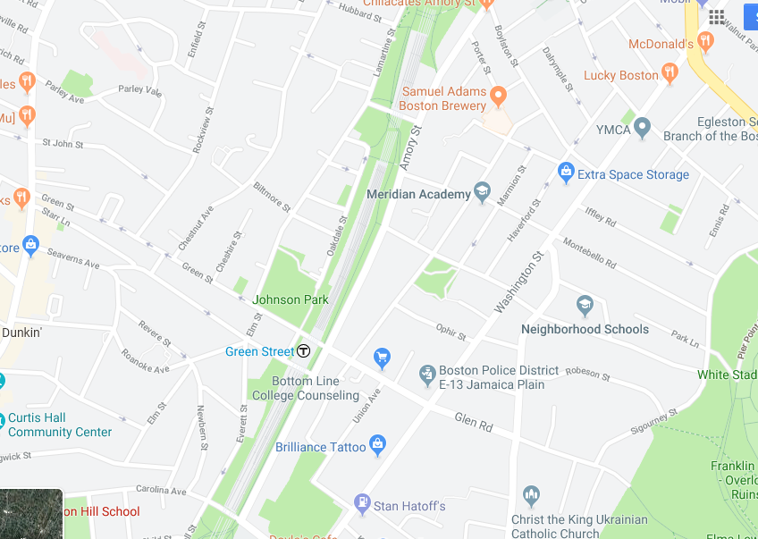

Example: Adjusting the map in the other direction, I can now see Meridian Academy and a YMCA in Jamaica Plain.

**Step 3 Regular Google searches**

Now, do a few simple Google searches.

*Churches (your target neighborhood) (your city) (state)*

*repeat for schools, community centers, parks, and events*

You’ll probably come up with additional results this way that weren’t visible on the initial map search. This is where being familiar with streets and zip code(s) will be useful. It’s also a good idea to consult the map again—the organization may not have a specific listing there, but you should be able to use these indicators to determine if it’s in your target area and, if not, how far outside the target area it is.

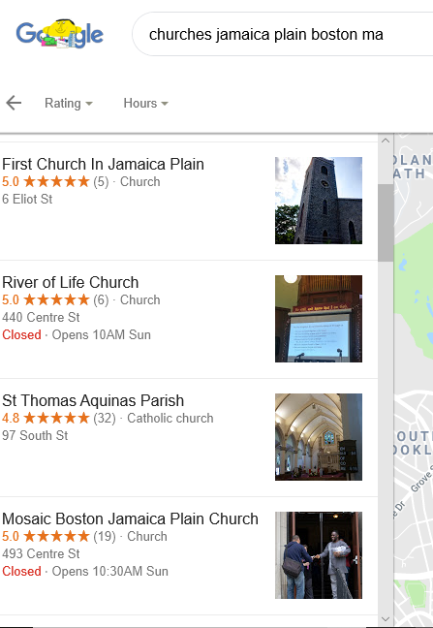

**What Information to Record**

When you find a location that you feel is relevant or fits what we’re looking for, record:

* + Name of organization
  + Address
  + Website
  + Social Media
  + Phone Contact
  + Email Contact
  + Any additional relevant/interesting information you feel we should know

Try to find a specific contact person:

* + Outreach coordinator
  + Pastor
  + Principal
  + Program director
  + Etc.

Finding a specific contact person is always preferable but, if not possible, just record the general organization information.

**Other Research Tips**

Find the public school system’s website for your city. Review the schools and determine which are in your target area. Many school systems have administrator/staff directories online where you can find specific contact information.

Also search for “rec centers” in your target neighborhoods. This may yield more results than “community centers.”

Make sure to review the website and/or social media for all organizations. Don’t assume that just because something is in a target area that it is a good contact. If a church doesn’t have a children’s ministry, a community center doesn’t have children’s programs, etc.—these may not be good contacts.

**Examples**

For a church:

Christ the King Ukrainian Catholic Church (in target area)

146 Forest Hills St.

Boston, MA 02130

617-522-9720

Fr. Yaroslav Nalysnyk, Pastor

[yaroslavnalysnyk@aol.com](mailto:yaroslavnalysnyk@aol.com)

<http://www.christ-the-king-ucc.org/index.php>

This appears to be a well-established church. Has Sunday services in both English and Ukrainian. The pastor is also a medical doctor who serves as a chaplain and ethics board member of the Dana-Farber Cancer Institute in Boston (well-known/regarded in the area). Has events (picnic and festival) listed on Google-- showing they are an active congregation.

For a school:

Mission Hill School (in Jamaica Plain, slightly outside of target area)

20 Child St.

Boston, MA 02130

617-635-6384

Ayla Gavins, Principal

Deborah Meier, Founder (<https://deborahmeier.com/>)

[info@missionhillschool.org](mailto:info@missionhillschool.org)

<http://www.missionhillschool.org/>

The Mission Hill School is a K-8 Public Pilot School in Jamaica Plain. It is “modeled on democratic principles” and was founded by learning theorist Deborah Meier in 1997. The curriculum is project oriented and emphasizes collaboration. The principal directs the school in consultation with both the Governance Board and Family Council.

For a community center:

Curtis Hall Community Center (in target area)

20 South St.

Boston, MA 02130

617-635-5193

<http://jpcommunitycenters.org/>

Jamaica Plain Community Centers is a non-profit community agency that operates both the Curtis Hall and Hennigan Community Centers (both in Jamaica Plain). Its mission is to provide Jamaica Plain residents affordable access to community/recreation activities for a small annual membership fee ($50/year for family membership). Curtis Hall has an indoor pool, gymnasium, and fitness center and has various adult/children classes.

*\*\*Note that I was not able to find a specific contact person or email address—I included all the information that I could.*

For a park:

Johnson Park Playground & Spray Deck (in target area)

Lamartine St/Green St.

Boston, MA 02130

617-626-4973

<https://www.mass.gov/locations/johnson-playground-spray-deck>

<https://www.bostoncentral.com/activities/spray/p1950.php>

<http://jamaicaplaingazette.com/2014/10/10/jp-kids-the-many-playgrounds-of-jp/>

Johnson Park has been voted one of the “best” playgrounds in Boston. It has several play structures for children of all ages and the largest spray deck/water park area in the city.

*\*\*Note that I was not able to find a specific contact person or email address. Parks (and community centers) may be more difficult to collect information for. Collect as much information as you can and consult multiple sources if needed.*

For an event:

The Jamaica Plain Music Festival

Takes place at: Pinebank Baseball Field (along Jamaica Pond)

When: September 7, 2019 from 12pm-7pm

The Jamaica Plain Music Festival is a 501c3 non-profit organization and is an annual event suitable for all age groups. For 2019, there will be 21 local bands, food trucks, and kids activities. Several local businesses sponsor the event and there are also donors.

Shamus Moynihan, President

[jpmusicfestival@gmail.com](mailto:jpmusicfestival@gmail.com)

PO Box 300346

Jamaica Plain, MA 02130

<http://www.jpmusicfestival.com/home>